Ecoscapes: Saltwater Android App

### Created by:

### Christopher Lubin, South Plantation High School

### Del-Roelle Thorpe, Miramar High School

### Nicholas Buckeridge, Nova High School

### July 2015

# Abstract

**Background:** This section of the paper will discuss our internship at the Museum of Discovery and Science and the exhibit we chose.

**Methods:** This portion of the report will explain the process of compiling information for the creation of this app. It will also describe the ways we worked as a team.

**Results:** This part of the paper displays the outcome of all our hard work. It will include pictures and an explanation of the way our app works.

**Discussion:** This section will offer suggestions on how we can improve our app.

**Conclusion:** The conclusion will describe our feelings on what we have accomplished and where to find our app’s project folder

**Acknowledgements:** This section will allow us to thank all the resources used

**References:** All content, technology, and graphic references that were key to the success of our project.

# Background

Our internship commenced in November of 2014. We met twice a month, every month, until July. During this time period, we became very well acquainted with the museum. We experienced all the hard work that goes into the IMAX theatre, the Ecoscapes exhibit, and the Otters exhibit. We also met with many of the people who work in the museum every day to find out what kind of things they thought were important to include in our app. We learned about Different departments at MODS, how MODS runs, MODS business model, IMAX and school programs, how MODS enhances STEM education and STEM center, how MODS affects the community, and marketing. Other steps we took to prepare for creating this app were making many, many charts to outline the whole process. First, we created charts to predict any possible future problems. Then, we split off into groups depending on the exhibit we chose. This group chose the Ecoscapes portion of the museum. The Florida Ecoscapes exhibit lets museum visitors experience some of the world’s most unique ecosystems. The exhibit features hundreds of living plants and animals. Once we knew what exhibit we were working on, we had to start planning out what we wanted for our app; however, our internship was not solely focused on this app. The internship exposed all of us to the STEM field and its importance. We had a homework assignment every month that explored different aspects of STEM. For example, one homework assignment asked us to “ describe how informal education centers help formal STEM  education, and how you feel your education in STEM will benefit from being at an informal education institution and how by you creating apps for the museum you may affect another personals formal STEM education.”. We also met people who work in different, not so obvious areas of the STEM field. For example, we’ve had the luxury of listening to a guest speaker from AT&T. The guest speaker explained to us the different things that they’d have to know and encounter if they worked for AT&T. We were given information on how STEM positions are becoming increasingly available now that technology is advancing as such an alarming rate. We were given information on the different radio towers they use, the difference between 2G, 3G, 4G LTE, how their services get from their company buildings to the consumers phone, and how telephone cables that are on almost every street work. We even got to look and touch on the actual wires they place inside the telephone cables and how they are moving to fiber optics because it’s much more efficient and can transfer much more data than ordinary copper wires.

Methods

Over the course of about 3 months, we collected as much data as we could on the different species of animals in the Florida Ecoscapes exhibit, the different ecosystems, and the plant life within each ecosystem. When we started the class at FAU, Christopher was assigned the role of UI Manager, Del-Roelle was assigned the role of Java Manager, and Nicholas was assigned the role of Graphics Manager. The UI Manager’s job was to setup the different buttons and layouts seen throughout the app. The Java Manager’s job was to write and debug the code in the app using the Java language. The Graphics Manager’s job was to create the various backgrounds and logos seen through the app’s different screens. Our different professors played a big role in helping us face the various problems we had during the process of refining our app. For example, if everything is not precise or something is misspelled in the Java code, there’s a strong possibility that the app won’t even run. Professor Shankar, Mr. Alain, and Mr. Santiago were the ones who helped us debug our code and made sure everything ran properly. Another problem we faced was that we could not place buttons exactly where we wanted them within the app screen. Mr. Santiago helped fix this problem by changing some of the code in our app and explaining to us the different layouts that can be used to easily move buttons to where we would want them to go. One more major problem that we faced was that we could not make the home screen look visually appealing to consumers and did not know what button layout would look best for our app. To rectify this, we got help from Professor McAfee and Demetrius who helped us contrast the different colors on our app so it wouldn’t look too bright or dark and also helped us with the different button layouts.

Results

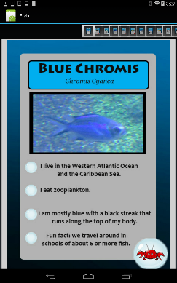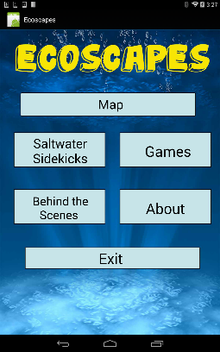Our completed Florida Ecoscapes app includes 6 buttons on the main screen. The top button named “Map” leads to an interactive map of the museum with the different exhibits that can be clicked on for more information. The top left button named “Saltwater Sidekicks” leads to another page with 3 categories: “Fish”, “Coral”, and “Invertebrates”. All three categories provide specific information on the different organisms present within the Florida Ecoscapes exhibit. The third button on the main screen located in the top right named “Games” leads to a trivia game that asks questions about the different organisms within our exhibit. The user is asked 10 questions and tells the user how he or she did at the end of the game. The fourth button in the bottom left named “Behind the Scenes” leads to a screen that shows one of two videos. The purpose of this section is to show guests how things happen behind closed doors where they cannot see. In order to view the next video the user just clicks on the next button. The fifth button on the bottom right side is named “About” informing the user of all the details why the app was made and also acknowledging all of the parties that helped in the apps creation. The final button is the exit button which exits the app.

Discussion

Although given three weeks to create this app we have done our best to make it good but can always be improved. Some ways that this app could be improved is by fixing the behind the scenes page. Making the video fit the canvas and having a divided button that displays two different options “Tour and Interview”, change bubble noise to only sound when a button is pressed rather than continuously in the background, added the museum logo to more pages, making the saltwater friends gallery smother to swipe through, and also fixing up the trivia game in its entirety to be more suite for Ecoscapes saltwater exhibit. We also would have liked to add a tic tac toe game along with the trivia game to give users more options to play with.

Conclusion

We unanimously feel very proud of how our app turned out despite the time constraints and starting off with limited knowledge of what we were about to get into. Although we would have liked to have added more features we are content with what we have. As a group we are happy with all the effort and progress put into this program, starting off as total strangers becoming good friends making a team to create an app from almost scratch. This link shows how to get to our project folder

https://github.com/MODSApps/Ecoscapes-Salt-Water-App/tree/master/Assignment%206